FINANCIAL POLICIES AND BUDGET SYSTEM
EXECUTIVE SUMMARY
2006 – 2010 period witnessed dramatic changes of Vietnamese economy: in the first two years (2006 – 2007), the economy continued favourable development momentum; however, to ending years of the planning period, particularly since quarter II/ 2007, the economy experienced climbing inflation, continued by global economic crisis and regression which resulted to adverse aftermaths in the national economy. However, Vietnam has overcome such difficulties and somehow maintained macroeconomic stability, sustaining encouraging economic growth rate with an average growth rate o7 7 percent/ year during 2006 – 2010; socio-economic standards have also been improved significantly.
Fiscal policy and state budget system have made major contributions to such results, with clear manifestations in macroeconomic tools, production development orientations, market regulation, price stabilization, and social living standards, etc. Fiscal policies have been deployed in a flexible way and in close interaction and coordination with other macro-economic policies, especially monetary policies. Tax policies have also experienced reforms toward being more adaptive to market mechanism and consistent to international practices. State budget has been restructured toward reducing subsidy expenditures, while increasing development investment expenditures, with priorities focusing on important socio-macro economic development and social unrest solution.
However, there are still some shortcomings in fiscal policies and state budget system, such as: limited stability and sustainability in resource mobilization; weaknesses and inefficiency in national financial allocation, unsolved wastefulness; reforms of financial system for non-productive agencies have not satisfied planned targets, lacking proper coordination between the State and private sectors in public services supply, creating further burden to state budget; negative fiscal policy, lacking close and consistent linkages with monetary policy, etc. These shortcomings have resulted to and sustained inherent weaknesses of the national economy over the last time, particularly persisted macroeconomic unbalances.
This working paper review the operation of fiscal and state budget system in Vietnam over the last time, focusing on some important issues, including: budget revenue and expenditure, state budget balance; state budget decentralization; and relations among different state budget levels, etc. Thereby, providing some recommendations for enhancing effectiveness and enforcement of fiscal policies and state budget system in the time to come, promoting national socio-economic development.

I. FISCAL POLICIES IN VIETNAM OVER THE LAST TIME
Since 2006, fiscal policies have been deployed on a proper basis with the country’s economic conditions. Policy activities (loosening, tightening, and cautious packages, etc) have been carried out in a rather flexible way to limit weaknesses of the economy and to achieve important targets, such as: economic growth, macroeconomic growth, and social security, etc. This section will look at the insight of issues regarding fiscal policies and state budget system since 2006.

1. State budget revenue
Reviewing state budget revenue and expenditure over recent years in Vietnam, it is possible to see that both revenue and expenditures have continuously increased year by year, and implementation of budget revenue and expenditure in reality has also been higher than planned (see figures below). However, it is possible to see that state budget deficits have also been an existing matter and the gap tends to widen.
Figure 1. Implementation of budget revenue and expenditure, 2006-2010 (VND bil.)
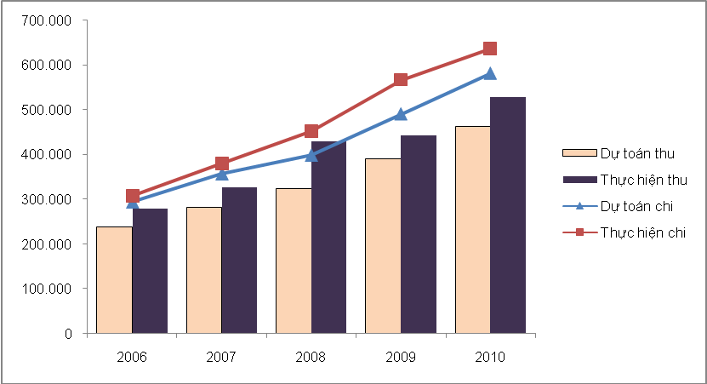 Source: GSO

Planned revenue
Implted revenue
Planned expend..
Implted expend.

Figure 2. State budget deficit, 2006 – 2010
Share of deficit in GDP (%)
Deficit (VND bil.)

Source: GSO

II. CURRENT STATE BUDGET SYSTEM IN VIETNAM
- The organization of state budget system
State budget sistema is the total budget of different state authority levels. The organization of the state budget system is influenced by many factors, especially the nation’s social regime and administrative area division. Generally, state budget system is organized basing on national administrative structure. (figure 3)

2. Relationship among state budget levels
Relationship among different state budget levels are reflected by state management decentralization regarding state budget revenue and expenditure with a view to improving efficiency of state budget performance.
Relating to management decentralization, assigning sources of revenue and expenditure to each state budget level is the core issue to create favourable financial conditions for governmental authorities of different levels to participate in the organization, mobilization, allocation, and usage of the state’s collective monetary fund for implementing defined functions and tasks.
Figure 3: Current intertwined state budget model in Vietnam
STATE BUDGET

CENTRAL STATE BUDGET
LOCAL BUDGET

PROVINCIAL BUDGET

DISTRICT BUDGET
Commune budget

3. Comments on the state budget system
First, the most noticeable achievement of Vietnam is that the state budget system has been legislated with clear decentralization, transparency, and consictence, creating legal basis for enhancing management and usage efficiency of the state budget.
Second, state budget has been restructured toward reducing subdidies while increasing expenditures for development investment, focusing on priorities of socio-economic development tasks and solving social issues.
Third, state budget system in Vietnam is organized basing on an “intertwinned”, which allows to guarantee consistency and enfored obeidience of various state budget levels.
Forth, state budget system in Vietnam is unique and unified, there is only one state budget system, and thus, managed and controlled thoroughly by the central government.
However, on the other hand, there remain some weaknesses also in the current state budget system in Vietnam. Particularly shortcomings relating to the unique and unified charateristics of the system, as well as enforcement of the system as a financial law. Besides, there are other limits in terms of management decentralization, particularly regarding issues of budget contingency by decentralized ministries, departments, and industries; reallocation of 5 revenue sources (i.e. land use transformation fees, land use and housing fees, business rates, agricultural land tax, and land and housing register fees) to commune governments; mechanism of revenue adjustment as unexpected increase or decrease araised; and supports from local budget for central agencies located in the locality.

III. SOME RECOMMENDATIONS TO COMPLETE FISCAL POLICIES AND STATE BUDGET SYSTEM IN THE FUTURE
- Recommendations for fiscal policies

1.1. In short term
First of all, is is advisable to promote saving and effective usage of state budget expenditures, in both terms of development investment and regular expenditures. Second, it is necessary to accelerate development of financial markets and services, promoting SOEs equitization and rearrangement as scheduled, developing stable and transparent securities and capital markets, etc.

1.2.In medium and long terms

Measures and solution for inflation curbing, macroeconomic stabilization, and economic growth acceleration should be reviewed for medium and long terms basing on model presented below.

Figure 4: Model for fiscal policy related measures
To define proper economic roles played by the Government
To reduce public investment and procurement
To enhance quality of public investment examination
Reduce wastefulness of public expenditure
Increase goods supply
Increase state budget revenue
To encourage private sector development
Increase effectiveness of public expenditure
To ensure basic macro-economic balance
To promote growth, macro-stability, and inflation control

2. Recommendations for state budget system
Under framework of the working paper, recommendations are provided, focusing on issues as follows:
- Ensuring collectiveness and unity of the national state budget.
- Encouraging dynamics and self-relience of local authorities of different levels.
- Reducing overlaps in the state budget system.
- Developing the law on state budget to a financial law.
- Providing more clear definition of state budget scopes.
- Allowing budget contingency in decentralized ministries, departments, industries, and sectors.
- Recaculating allocation of revenue from 5 commune-based sources.
- Providing adjustment mechanism to respond to unexpected increase or decrease in revenues.
- Allowing supports from local budget for central agencies allocating in the locality.
- Empowering more to local authorities.
- Creating proper mechanism for promoting state budget supervision performance and enforcement.

